**ME 111 Engineering Drawing [July-Nov 2017]**

**Indian Institute of Technology Guwahati**

**Projection of Points & lines: Tutorial 3 (Monday Batch)**

1. Draw the projections of the following points on the same ground line keeping the distance between the projectors equal to 25 mm. (*Attempt any five*)

i. Point A, 35 mm above HP and 25 mm behind VP

ii. Pont B, 25 mm below HP, 30 mm behind VP

iii. Point C, 30 mm below HP and 30 mm in front of VP

iv. Point D, 40 mm above HP and 25 mm in front of VP

v. Point E on HP and 45 mm behind VP

vi. Point F on VP and 30 mm above HP

2. The length of the top view of a line parallel to the VP and inclined at 45º to the HP is 50 mm. One end of the line is 12 mm above the HP and 25 mm in front of HP. Draw the projections of the line. Determine its true length.

3. A straight line AB of 40 mm length has its ends A 10 mm from HP and 15 mm from VP. Draw the projections of the line if it is parallel to vertical plane and inclined at 30º to horizontal plane. Assume the line to be located in the fourth quadrant.

4. FV of line AB is 500 inclined to XY and measures 55 mm long while its TV is 600 inclined to XY line. If end A is 10 mm above HP and 15 mm in front of VP, draw its projections, find TL, and inclinations of the line with HP & VP.

**ME 111 Engineering Drawing [July-Nov 2017]**

**Indian Institute of Technology Guwahati**

**Projection of Points & Lines: Tutorial 3-Key (Monday Batch)**

1. Draw the projections of the following points on the same ground line keeping the distance between the projectors equal to 25 mm. (*Attempt any five*)

i. Point A, 35 mm above HP and 25 mm behind VP

ii. Pont B, 25 mm below HP, 30 mm behind VP

iii. Point C, 30 mm below HP and 30 mm in front of VP

iv. Point D, 40 mm above HP and 25 mm in front of VP

v. Point E on HP and 45 mm behind VP

vi. Point F on VP and 30 mm above HP

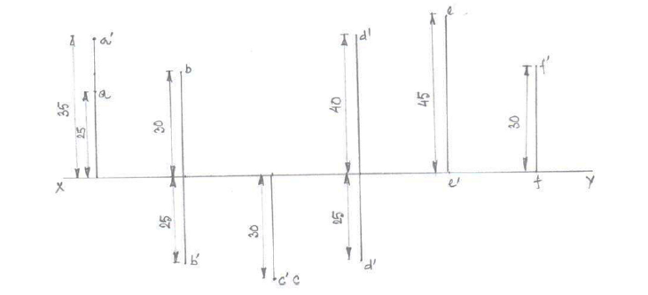

2. The length of the top view of a line parallel to the VP and inclined at 45º to the HP is 50 mm. One end of the line is 12 mm above the HP and 25 mm in front of HP. Draw the projections of the line. Determine its true length.

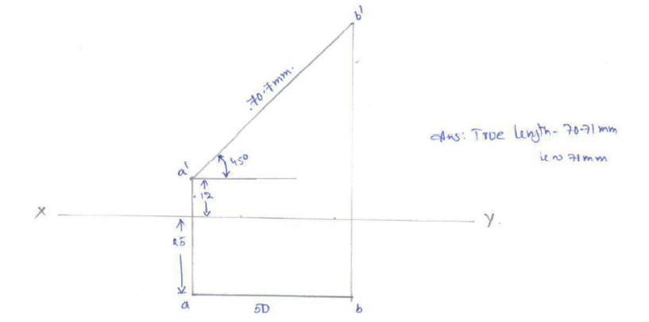

3. A straight line AB of 40 mm length has one of its ends, A 10 mm from HP and 15 mm from VP. Draw the projections of the line if it is parallel to vertical plane and inclined at 30º to horizontal plane. Assume the line to be located in the fourth quadrant.

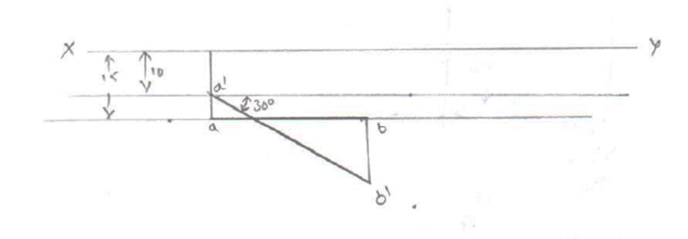

4. FV of line AB is 500 inclined to XY and measures 55 mm long while its TV is 600 inclined to XY line. If end A is 10 mm above HP and 15 mm in front of VP, draw its projections, find TL, inclinations of line with HP & VP.

